Federation/Foundation logo 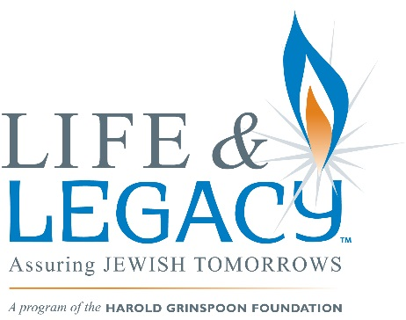

Federation/Foundation Title for application

Thank you for applying to participate in (Foundation/Federation’s) LIFE & LEGACYTM program, an initiative of the Harold Grinspoon Foundation (HGF). LIFE & LEGACY program is a results-oriented 4-year program that assists communities across North America to promote after-lifetime giving to build endowments that will provide financial stability to local Jewish day schools, synagogues, social service organizations and other Jewish entities. Through training, support and monetary incentives LIFE & LEGACY motivates Jewish organizations to secure legacy gifts, steward donors and integrate legacy giving into the philanthropic culture of the Jewish community. In so doing, we all achieve our shared goal of a vibrant Jewish life in (community) now and for future generations.

The (Federation/Foundation), in partnership with HGF will provide training, consulting, coaching, and marketing along with incentive grants each year. We hope the incentive grant will encourage your organization to prioritize legacy giving and evolve from a fundraising culture to a culture of philanthropy.

Participation in the LIFE & LEGACY program will require each organization’s legacy team (comprised of at least one professional and three lay leaders) to attend periodic group trainings and team consultations.

(Any other requirements you want to include such as money resulting from legacy gifts obtained through this process being placed at your Foundation, submitting quarterly reports in a timely fashion etc)

(Any other introductory information you want to share with applicants)

To apply, please complete this application form and submit by the deadline noted below. Please feel free to call or email (contact person, phone, email address) with questions.

Return the Application no later than (time) on (date) to:
Contact Name
Federation/Foundation name
Address
City, State, Zip Code
Federation/Foundation logo

Foundation/Federation Title for application

Name of Organization:

Year Established:

Address:

Telephone: ( ) Fax: ( )

E-Mail: Website:

Accreditation Information and/or Affiliation:

Contact Person/Title:

Senior Professional Leadership:

Development Director:

Number of Members:

Number of Donors:

Number of Clients:

Number of Students:

Mission Statement and Organizational Goals:

Summary of organization’s history.

- Describe your organization’s current fundraising activities and goals including annual campaigns, capital campaigns, endowment campaigns and special events.

- Does your organization currently have an endowment? If so, what is the current market value? How was the endowment raised?

- What is your organization’s endowment spending policy? How much does the endowment provide to your organization annually? How are those funds currently used?

- Who currently manages your endowment assets? Who in your organization oversees your investments?

- Has your organization been promised bequests or other endowment gifts? If so, please describe the nature of these commitments.

- Has your organization received realized bequests or other planned gifts in the last five years? If so, how many and what was the dollar value?

- Who is currently responsible for the record keeping and administration of bequests or endowment gifts?

- Who on your team will be responsible for submitting LIFE & LEGACY quarterly reports in the required Excel format?

- Please list the 4 – 6 lay leaders who will make up your Legacy Team

______________________________________________________________________________

- Have the individuals listed been apprised of your application and their potential involvement in this program? ______Yes ______ No

- Are the members of your Legacy Team willing to:

  - Commit to a legacy gift within the next two years? ____Yes _____ No

  - Make a presentation at a board meeting asking board members to commit to a legacy gift within the next two years? ____ Yes ____ No

  - Actively participate in legacy conversations with donors? ____ Yes ____ No

  - Keep the board apprised of the LIFE & LEGACY process and efforts to secure legacy commitments? ____ Yes _____ No

  - Commit to attending LIFE & LEGACY training sessions? ____ Yes ___ No

  - Commit to preparing and implementing a Legacy Plan? _____ Yes ____ No

- Has your organization’s President/Board Chair, Rabbi, Executive Director/CEO, Head of School and Development Director (all that apply) been apprised of your application and potential involvement in this program? ______ Yes ______ No

- Please attach a list of your current board members.

________________________________________________________ _________________
Printed name of individual submitting the application Date

