(printed on two sides of cardstock and folded into a greeting card)

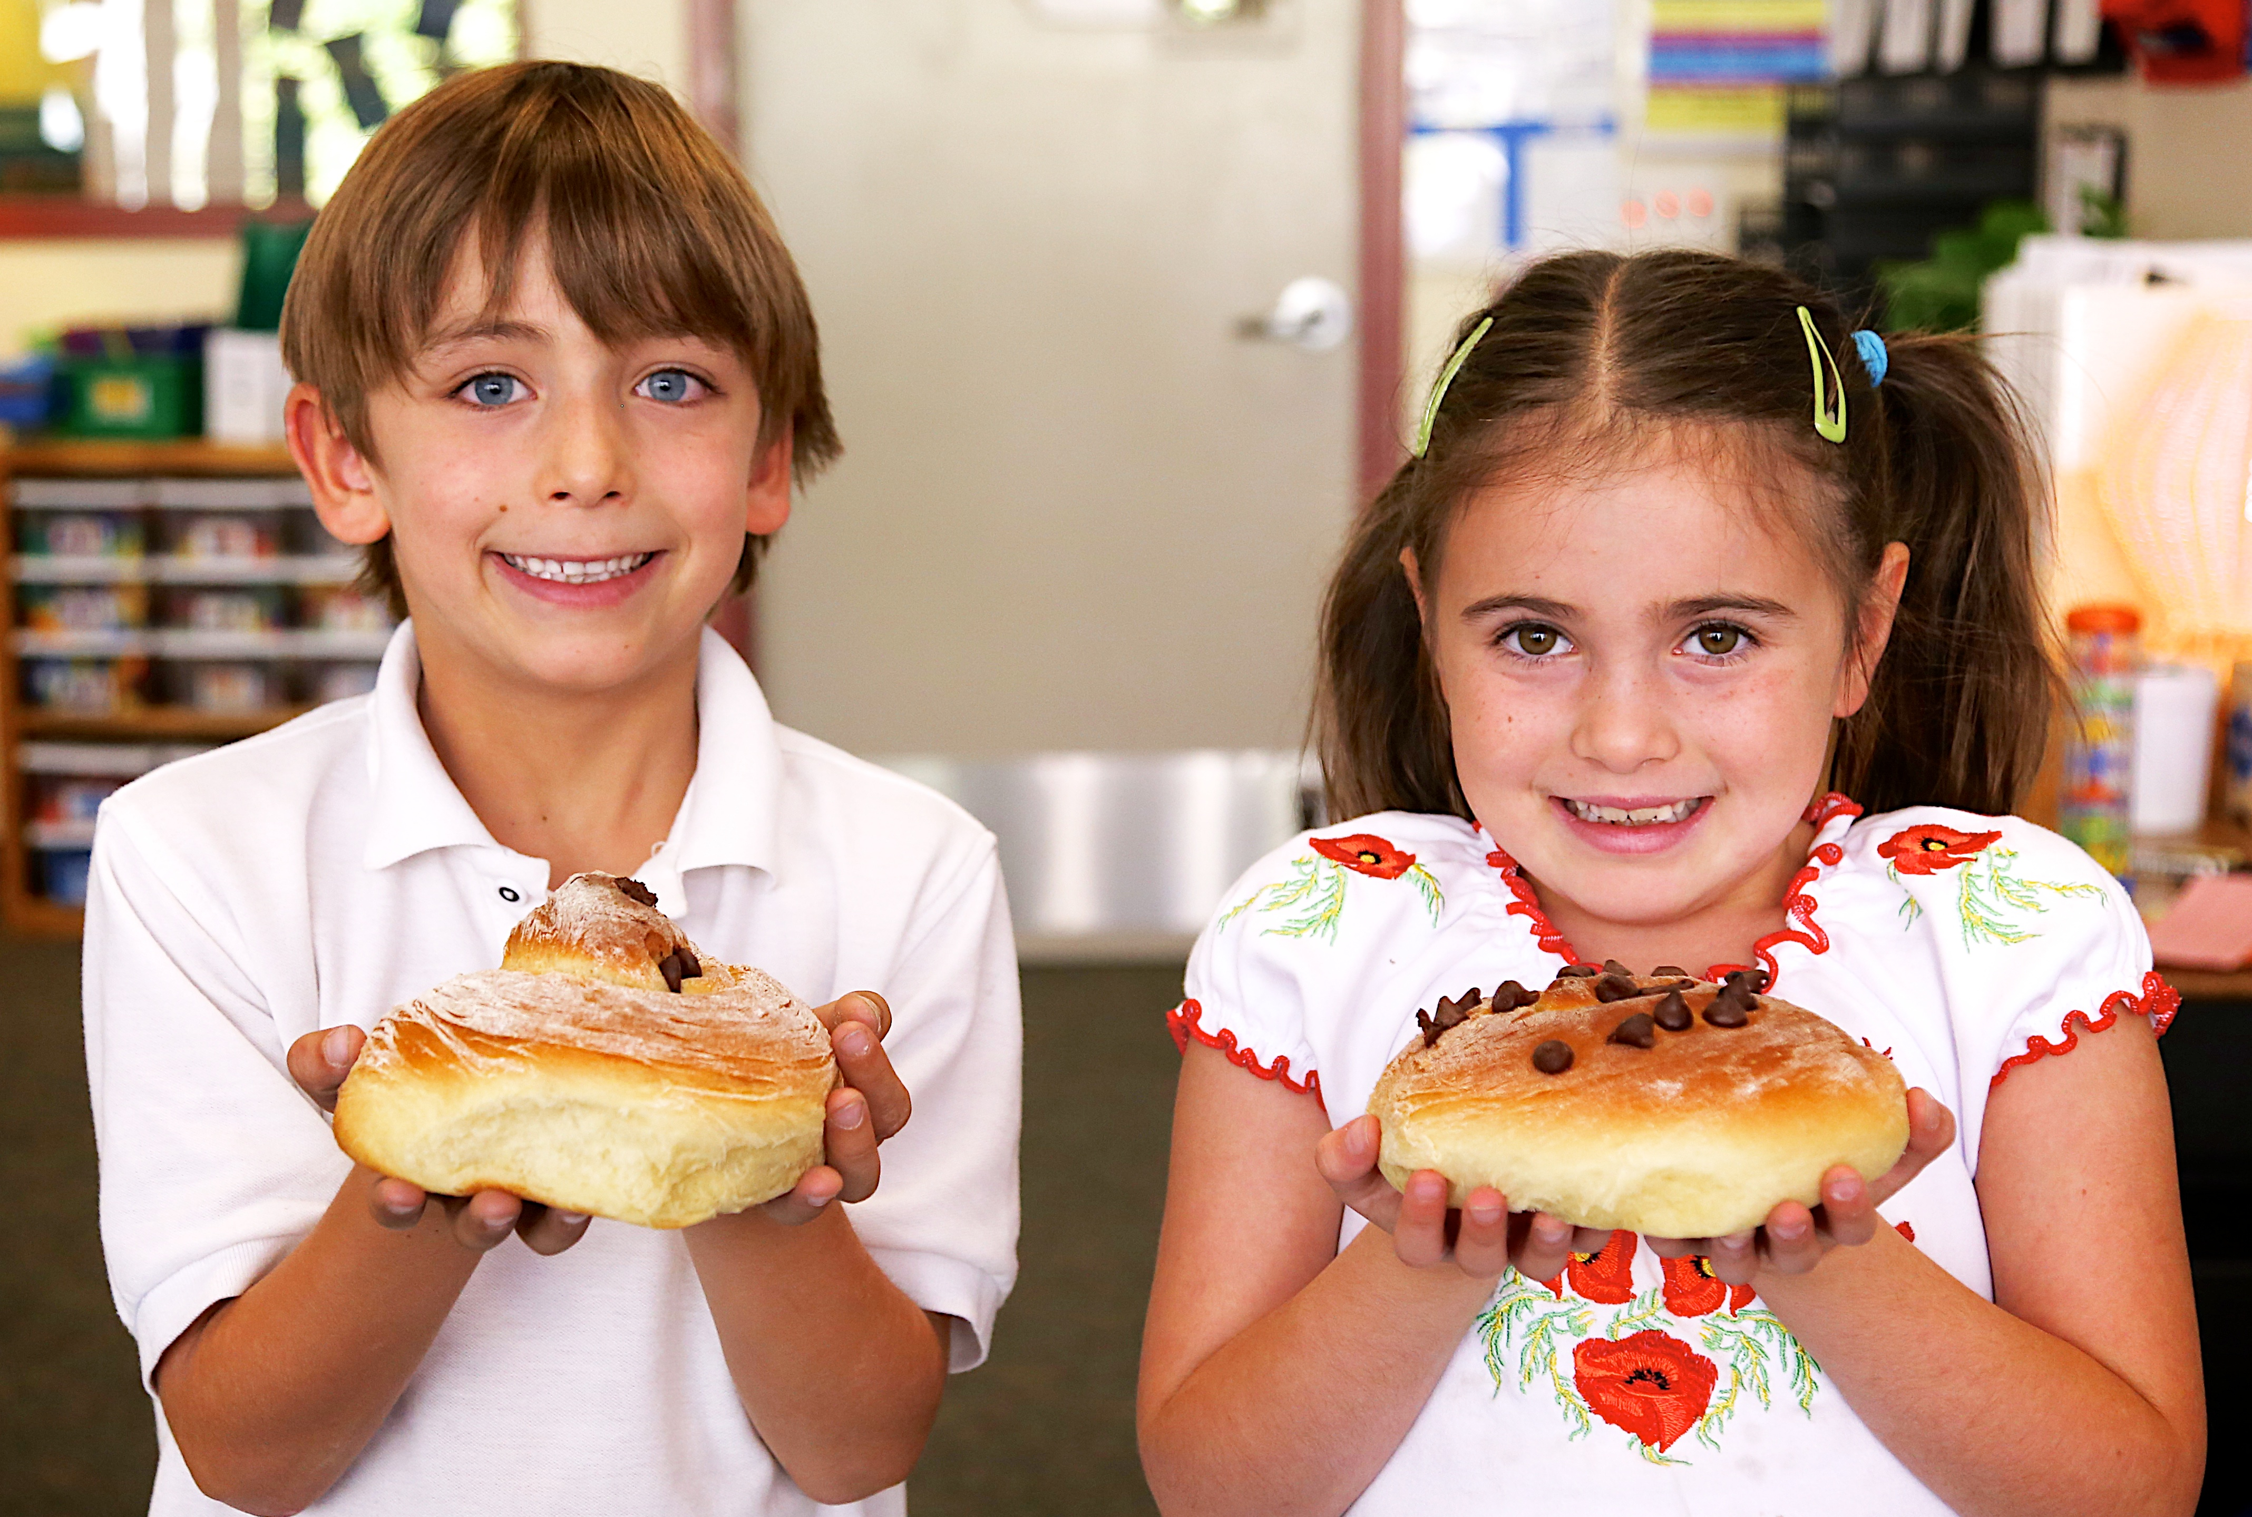

You are ensuring our Jewish tomorrow. We want to thank you today.

Please join us for a special, musical Shabbat in your honor.

L’Dor V’Dor/Generation to Generation Legacy Shabbat
Coming together to share our joyful traditions and to thank
the generous leaders who are making the Contra Costa Jewish Day School
a part of your legacy. You are a blessing to our community.

Friday, October 16, 2015 at 7:30pm
Congregation B’nai Tikvah, 25 Hillcroft Way, Walnut Creek

Special thanks to our friends at Congregation B’nai Tikvah.
Our partners in the Create a Jewish Legacy program, they have invited us
to join them in hosting this Shabbat to honor all of our legacy donors.
Please respond by October 9th to eden@ccjds.org or (925) 284-8288.

L’shanah tovah and todah rabah!



